Lab 6: Data Visualization

Instructions
- Create a Quarto file called lab_6_data_visualization
- Copy and paste the questions/prompts into the markdown file as text. Use a header tag for each question #.
- Write any required code in code chunks directly beneath the question.
- Submit both a rendered .docx file and your .qmd file to ELMS before 11:59pm.
- See the 'lab assignment demo' file (.qmd) on Jupyter for an example. Do not directly edit this file—create your own Quarto document instead.
Note: For all questions, be sure to recreate all aspects, including plot titles, plot themes, and axis labels. The colors are simple named colors in R. Try your best to match the colors.
Data description: For all questions, we will use the college_data.csv and hs_data.csv datasets on Jupyter. A description of the variables is below:
- ID: The student ID number.
- woman: The gender of the student where 1 = "Woman" and 0 = "Man".
- white: Whether the student was White where 1 = "White" and 0 = "Non-White".
- hs_size: The size of the student's high school graduating class.
- SAT: The rank of the student in their high school graduating class.
- hs_percentile: What percent the student ranked in their high school graduating class.
- stud_ath: Whether the student was an athlete in college.
- SAT: The SAT score of the student.
- col_GPA: The GPA of the student at the end of their first year of college.

Question 1
a.) Read college_data.csv into an object called college and hs_data.csv into hs.
b.) Create a total dataset called full_dat where you inner join college and hs by ID.
c.) Convert stud_ath to a factor.
d.) Create a new variable called gender where the values are Woman or Man. Convert gender to a factor. Create a variable called race where the values are White or Non-White. Convert race to a factor. Drop the white and woman columns from the data frame. Hint: In the mutate statement, we can use newvar = ifelse(oldvar == value, "valifTRUE", "valifFALSE").
Try to do d all in one statement if you can!

Question 2
Recreate this figure in ggplot2.

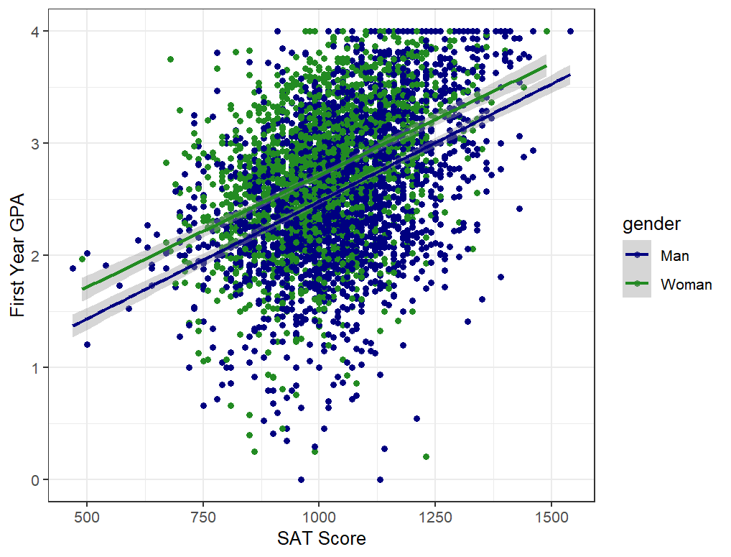

Question 3
Recreate this figure with the line representing the overall median of the col_GPA variable. (Hint: the fill colors are orange and pink and the fill alpha is .50.)

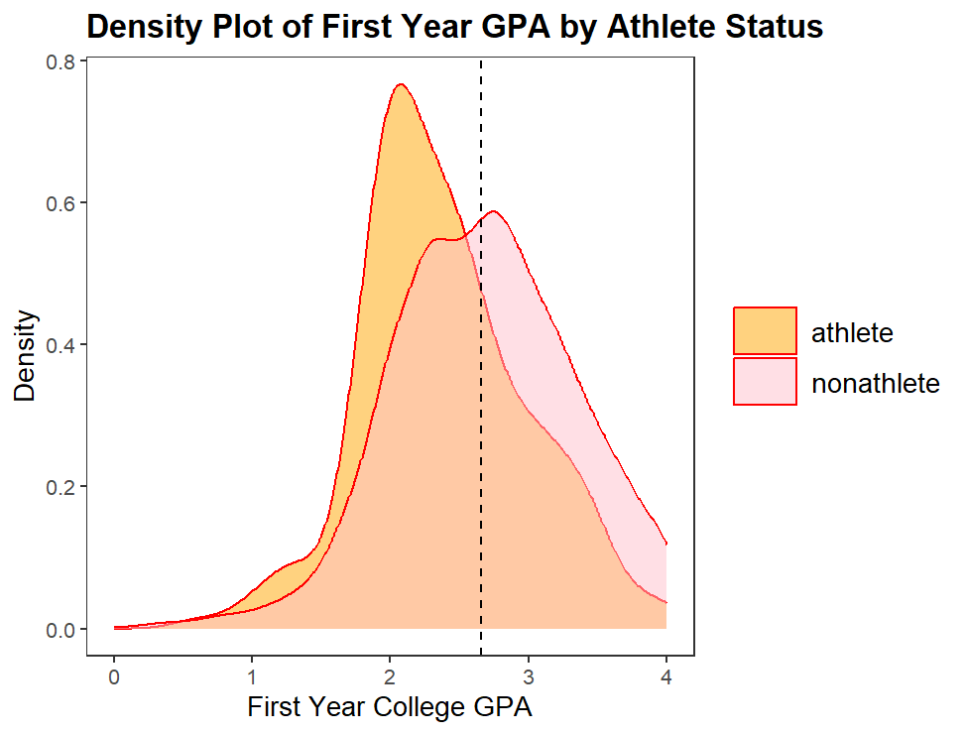

Question 4
Recreate this figure using the built-in mtcars data frame.



